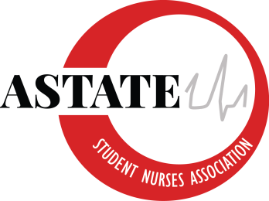

Arkansas State University Student Nurses’ Association
Board of Directors Meeting
*OFFICER HANDOFF*
April 28th, 2021
12 pm
Zoom
Agenda

- Call to Order: 12:02 pm

- Roll Call:
President: Charlee-Beth Patterson - absent
Vice President: Victoria Woods
Secretary: Abby Hanlon
Treasurer: Sheila Inman
NEC Chair: Jessica Brown
BTN Chair: Jenna Glenn
Webmaster: Brayton Ragsdale
Public Relations: Cody Cockrell
Senior Class Representative: Elizabeth Johnson
Junior Class Representative: Dylan Western - absent
Sophomore Class Representative: Emma Farmer
Accelerated Class Representative: Anna Bristo - absent
Faculty Advisor: Addie Fleming
Faculty Advisor: Kayla Travis
Visitors: none

NEW 2021-2022 SNA Board
President: Emma Farmer
Vice President Abagail Gatlin -absent
Secretary: Kayte Cook
Treasurer: Hannah Farmer
Nominations and Elections Chair: Blakeleigh Garrison
Breakthrough to Nursing: Madison Terrell
Webmaster: Ashton Archer
Public Relations: Heath Alexander
Senior Representative: Zack Spann
Junior Representative: Macey Jones

- New Business/ Follow Up
Officer Hand-Off (Break-Out Rooms)
Traditional BSN Pinning Ceremony
- Thank you, Liz for all of your hard work!
- Liz needs help creating the picture slideshow
- We have the Fowler Center booked from 10 am to 9 pm on Friday March 7
- Board members and volunteers will arrive at 5 pm and the ceremony will begin at 6 pm. Attire is professional
- We will have a live stream link on Youtube that will be sent out for relatives to watch
Accelerated BSN Pinning Ceremony—Anna Bristo
- Will possibly be held in the Convocation Center
- Current checking $16, 265.97
- Jenna made a motion for SNA to make a donation not to exceed $300 for the accelerated BSN pinning ceremony. Brayton Seconds. No opposed. Motion passes on 4/28.

Strategic Planning Meeting for new board: 8 am -12 pm, May 4th

- Discussion

Jenna made a motion to end the meeting at 12:35. Brayton seconds the motion. No further discussion. Motion carries. Meeting adjourned at 12:35 pm.

